Team 2: Bharat Khandelwal, Mike Sanders, Satya Phanindra Kumar Kalaga, Will Kimball

Professor Ning Rui

DATS 6103: Introduction to Data Mining

April 26, 2024

**Fair weather climate change denial: Assessing the impact of local weather on individual’s opinions on the existence of climate change**

Satya Phanindra Kumar Kalaga, George Washington University

Bharat Khandelwal, George Washington University

Will Kimball, George Washington University

Mike Sanders, MS, EdS, George Washington University

# Abstract

Climate change denialism is a socially disruptive behavior that has plagued environmental reform for decades. The underlying causes of this irrational belief have been speculated on and tested repeatedly with no firm consensus having been reached. While researchers have found correlations between an individual’s experiential weather and their opinions of the existence of climate change, much of this work has been based on smaller scale, point in time studies. We seek to advance the understanding of climate change denial by incorporating local weather data into a large dataset collected by a nationally representative longitudinal survey of climate change opinions. To do so, we build a predictive model of believing in climate change based on the demographic and experiential weather patterns of survey respondents in the US between 2008 and 2022.

Using a logistic regression model we find that how individuals experience local weather likely does influence their opinion of if climate change is happening. We also postulate that there is some impact on opinions of climate change derived specifically from the increasing rate of severe storms and overall trends in rising local temperatures. Finally, we find that el Nino/la nina weather patterns do seem to have some impact on local weather experience and thus should be considered in future work on this subject.

# 

# Introduction

The public’s opinion on climate change impacts the ways that our society and government can respond to climate change. Understanding the mechanisms behind an individual's perception of climate change can help policymakers and advocates engage with the public more effectively. The Intergovernmental Panel on Climate Change in its recent sixth assessment report noted that international action and cooperation would be needed to address climate change[1]. In order to enact policy on such a large scale, the United States would need to first convince its citizens of the existence of climate change. Many studies have previously noted effects that things such as political party and ideology have on one’s opinion of climate change, with some studies including limited measures of local climate perception[2]. This study aims to study what factors contribute to opinion on climate change, incorporating several climate conditions to learn more about the effect of weather patterns on opinion of the existence of climate change.

In order to determine the effects that changes in weather have had on the opinion of the existence of climate change, we devised several questions to guide our research. These questions allow us to determine whether changes in weather had a significant effect on people in the United States’ opinion on the existence of climate change, and which weather conditions were the most prominent in affecting people in the United States’ opinion on the existence of climate change.

1. How have global temperature changes impacted opinion of the existence of climate change since 2008 in the United States?
2. How have temperature and rainfall impacted the perception of climate change occurring in individuals in the United States since 2008?
3. How has the El Nino/La Nina weather pattern impacted public perception of climate change since 2008 in the United States?
4. How have local weather patterns impacted the perceptions of climate change among different demographic groups since 2008 throughout the United States?
5. How has extreme weather impacted public perception of climate change since 2008 in the United States?

By answering these questions, we will give valuable insight on the things that predominantly affect a person’s beliefs about climate change. With this information, policymakers and advocates can more effectively communicate with the public on these topics, allowing them to engage with communities in more meaningful ways. While there has been a lot of research regarding how things such as political party and ideology affect one’s opinion on climate change, this study will dive deeper into other factors that may impact a person’s opinion on climate change.

# Background

Anthropogenic global warming stems directly from the increase in greenhouse gas emissions which helped power the industrial revolution in the 1800s[3]. However, it wasn’t until NASA scientist James Hansen testified before the U.S. Senate that the agency had detected greenhouse effects occurring in the earth’s atmosphere in 1988[4] that the U.S. public in general became aware of the staggering costs of technological advancement[5].

For the most part, the emission of pollutants as a result of industry has been treated as a typical tragedy of the commons problem as non-particulate air pollution is generally invisible and the costs of pollution are rarely borne by the polluters themselves. Rather, the costs of pollution are borne by everyone individually spreading the impact out and pushing the true costs to future generations. This makes the complexities of greenhouse gas emissions and the related climate change difficult for individuals to understand, realize its impact, and take action to correct.

Further complicating the public’s perception of human caused climate change is the direct action of an organized disinformation campaign led by the polluters themselves to confuse the issue. Even before global warming caught the attention of the nation, a coalition of industries (including fossil fuel companies) and conservative foundations/think tanks spread denials and false information through scientific publications and media channels with the goal of creating confusion about the causes of and impacts from global warming.

While extremely reliable scientific research has continued to show that the world is warming and recent extreme weather events such as unprecedented heat waves and historically intense storms, there remains a segment of the population that denies the existence of global warming. Psychologists have postulated that the underlying cause of the intransigence may lie in an “environmental numbness” which makes individuals unaware of their physical surroundings, especially if they cause them no immediate discomfort[6]. In the context of climate change, this means that it’s easy for people to deny climate change if their current environment is comfortable. For many people, this makes them literally fair weather climate change deniers.

The perception of local weather is therefore a ripe topic for analysis when considering why climate change denial has been so persistent. Research has shown that temperature[7] and precipitation[8] correlates with an individual's perception of climate change. However, the evidence that experiencing extreme weather is more mixed[9] with the type of extreme weather[10] potentially more related to these perceptions than the frequency or scale[11]. Further, the impact of these extreme conditions may moderate in impact over time as individuals reset their baseline beliefs about what “normal” climate means[12]. Even so, the impacts of long term extreme weather trends may still hold some explanatory power on the perception of climate change[13].There is also some evidence that regional differences may also exist between the impacts of weather on climate change belief[14].

# Dataset

Even though there has been significant research comparing local weather perception with personal belief in climate change, the majority of the studies we encountered were small scale international studies which relied on one-time survey methods to collect opinion data. Given the potentially time sensitive nature of climate change opinion, we chose to utilize a large, longitudinal survey on public perception of climate change conducted by Yale University’s Program on Climate Change Communication (YPCCC) and the George Mason University Center for Climate Change Communication (Mason 4C). The survey, Climate Change in the American Mind: National Survey Data on Public Opinion (2008-2022), is a nationally representative survey of U.S. adults aged 18 and older collected between 2008 and 2022[15]. This dataset contains more than 31,000 observations across 26 survey waves with information on demographics, opinions of climate change, and geography.

The YPCCC data does not contain local weather information. So, to test the impact of local weather on public perception of climate change we collected data from NOAA’s NOW Data system. Data on precipitation and temperature is provided monthly at the station level by each weather division but is not easily accessible as a single database. The YPCCC data contains only information on the region a respondent lives in which limits our choices when incorporating local weather data. We chose to use the local weather data representing the largest fraction of the population of a region by incorporating the temperature and precipitation data from the city center of the largest city in each region.

We also wanted to incorporate information about extreme weather into our model. To do so, we collected data from FEMA’s OpenFEMA system on disaster declarations[16], severe storm warnings[17], and spending on disaster relief[18]. As this data is also geographically collected, we consolidated the information to regional totals to allow for merging with the climate opinion data.

Finally, we wanted to control for global variations in weather which might influence local weather patterns. To do so we collected data on global temperature trends from NASA’s climate center[19] and seasonal weather patterns (el Nino and la Nina) from NOAA’s Climate Prediction Center[20]. These values are incorporated as annual indexes.

# Exploratory Data Analysis

Our datasets were sourced from large, well maintained, databases which helped reduce the incidence of missing and miss-coded data. As part of our variable selection process, we chose to avoid variables with missing data but found the most common demographic data to be complete within the YPCCC data file. Similarly, the weather data from NOAA and NASA was complete across all years and regions. Data from FEMA is from an administrative source and stored as a time of occurrence observation (accounting data) meaning there was no way for us to determine if missing data was a true zero or missing. According to FEMA guidance, we treated missing values as true zeros.

The remaining variables we considered are shown in Table 1 below,

**Table 1**: Variables Considered for Inclusion in Research

| Var Type | Var description | Type | Min | Max |
| --- | --- | --- | --- | --- |
| Independent | "Is climate change happening?" | binary | 0 | 1 |
| Time | Year of survey | integer | 2009 | 2022 |
| Location | Region of the US | category |  |  |
| Demographic | Female | binary | 0 | 1 |
| Demographic | Age | integer | 18 | 97 |
| Demographic | Education level | category |  |  |
| Demographic | Income level | category |  |  |
| Demographic | Race | category |  |  |
| Demographic | Ideology | category |  |  |
| Demographic | Political party | category |  |  |
| Demographic | Religion | category |  |  |
| Demographic | Marital status | category |  |  |
| Demographic | Current employment | category |  |  |
| Weather | Average temp | integer | -50 | 150 |
| Weather | Snowfall | integer | 0 | 1000 |
| Weather | Rainfall | integer | 0 | 1000 |
| Extreme | Number of weather related natural disasters | integer | 0 | 1000 |
| Extreme | Number of severe storm warnings | integer | 0 | 1000 |
| Extreme | FEMA Spending (millions) | integer | 0 | 1000 |
| Global | el Nino/la Nina index | integer | -5 | 5 |
| Global | Global temp index | integer | -2 | 2 |

To better assess which of these variables might be useful in our research, we conducted an exploratory data analysis. We found the distributions of our continuous variables to be varied. Some variables, such as age and annual rainfall, resembled normal distributions, with some small amounts of skew. Other variables, such as the number of disasters and annual snowfall were heavily skewed and did not resemble normal distributions. Similarly, our categorical variables had a variety of distributions, with some such as gender and year being evenly spread across categories, while others such as income or education were not as evenly spread between categories. These insights into the distribution of our data later informed our choices for the methodology we pursued to model opinion of climate change. After learning the distribution of our variables, statistical testing was carried out to determine if there were any notable differences or relationships between our variables. Analysis of variance was performed on our non-binary categorical variables, while t-tests were performed for our binary categorical variables, and correlation testing was performed for our continuous variables. Due to our large sample size, many tests came back statistically significant. However, after accounting for effect size, many of these differences were revealed to be very small or even negligible. ANOVA revealed moderate differences between our groups, as described in the tables below. T-tests revealed some statistically significant results, but none had notable effect sizes.

**Table 2**: Analysis of Variance Results, colored by effect size (Cohen’s f2)[21]

| ANOVA Results | | Age | C_temp | Snowfall | Rainfall | Disasters | Storms | Spending | El_nino | G_temp | G_temp_lowess | Children | Adults | Population |
| --- | --- | --- | --- | --- | --- | --- | --- | --- | --- | --- | --- | --- | --- | --- |
| Education | Stat | 36 | 21 | 16 | 35 | 2.43 | 24 | 7.66 | 0.75 | 36 | 65 | 45 | 84 | 5 |
| P-value | 0 | 0 | 0 | 0 | 0.06 | 0 | 0 | 0.52 | 0 | 0 | 0 | 0 | 0 |
| Income |  | 11 | 1 | 2 | 2 | 7 | 22 | 7 | 3 | 49 | 82 | 3 | 56 | 5 |
| 0 | 0.19 | 0 | 0 | 0 | 0 | 0 | 0 | 0 | 0 | 0 | 0 | 0 |
| Race | 284 | 288 | 184 | 271 | 9 | 4 | 17 | 2.17 | 18 | 18 | 94 | 154 | 54 |
| 0 | 0 | 0 | 0 | 0 | 0.01 | 0 | 0.09 | 0 | 0 | 0 | 0 | 0 |
| Ideology | 108 | 3 | 3 | 6 | 3 | 15 | 1 | 3 | 18 | 24 | 14 | 5 | 19 |
| 0 | 0.01 | 0.01 | 0 | 0.01 | 0 | 0.3 | 0.02 | 0 | 0 | 0 | 0 | 0 |
| Party | 205 | 4 | 5 | 8 | 5 | 26 | 4 | 10 | 17 | 24 | 49 | 9 | 14 |
| 0 | 0 | 0 | 0 | 0 | 0 | 0 | 0 | 0 | 0 | 0 | 0 | 0 |
| Religion | 119 | 76 | 54 | 92 | 6 | 35 | 2 | 16 | 73 | 80 | 38 | 9 | 61 |
| 0 | 0 | 0 | 0 | 0 | 0 | 0.01 | 0 | 0 | 0 | 0 | 0 | 0 |
| Marital Status | 1937 | 3 | 3 | 4 | 3 | 2.5 | 1 | 0.26 | 3 | 4 | 121 | 391 | 12 |
| 0 | 0.02 | 0.02 | 0 | 0.01 | 0.03 | 0.53 | 0.94 | 0.01 | 0 | 0 | 0 | 0 |
| Employment | 3316 | 11 | 8 | 4 | 5 | 25 | 5 | 4 | 38 | 60 | 386 | 123 | 2 |
| 0 | 0 | 0 | 0 | 0 | 0 | 0 | 0 | 0 | 0 | 0 | 0 | 0.07 |
| City | 4 | 145080 | 10593 | 12476 | 450 | 1 | 165 | 1 | 2 | 3 | 10 | 6 | - |
| 0 | 0 | 0 | 0 | 0 | 0.16 | 0 | 0.62 | 0.04 | 0 | 0 | 0 |  |
| Year | 25 | 34 | 187 | 124 | 3616 | - | 1441 | - | - | - | 113 | 7 | 1 |
| 0 | 0 | 0 | 0 | 0 |  | 0 |  |  |  | 0 | 0 | 0.37 |

**Table 3**:T-test results, colored by effect size (Cohen’s d)[22]

| T-test Results | | Age | C_temp | Snowfall | Rainfall | Disasters | Storms | Spending | El_nino | G_temp | G_temp_lowess | Children | Adults |
| --- | --- | --- | --- | --- | --- | --- | --- | --- | --- | --- | --- | --- | --- |
| Happening | Stat | 3.57 | -1.75 | 2.74 | 3.78 | -1.79 | -9.67 | -4.56 | 0.36 | -8.76 | -12.18 | 5.22 | 3.03 |
| P-value | 0 | 0.08 | 0.01 | 0 | 0.07 | 0 | 0 | 0.72 | 0 | 0 | 0 | 0 |
| Female | Stat | 0.88 | 0.75 | -1.08 | -1.6 | -0.71 | 1.93 | -0.31 | -0.11 | -0.05 | -0.45 | -5.07 | 2.88 |
| P-value | 0.38 | 0.45 | 0.28 | 0.11 | 0.48 | 0.05 | 0.76 | 0.91 | 0.96 | 0.65 | 0 | 0 |

After performing a variety of statistical tests, we performed principal component analysis on our continuous variables, to learn about associations between our variables and to see if we could meaningfully reduce the dimensionality of our dataset before modeling. While our principal components themselves did not give any surprising insights, they allowed us to consolidate our continuous variables into a few categories.[23] The first principal component picks up largely on global trends, while the second, third, and fifth pick up on different regional trends, and the fourth is mainly demographic variables. This consolidated our 13 continuous variables into 5 components, helping to reduce the dimensionality of our dataset.

**Correlation Analysis**

Correlation analysis is a statistical technique used to measure and describe the strength and direction of a relationship between two or more variables. It helps in understanding how changes in one variable are associated with changes in another variable.However, correlation does not imply causation, meaning that even if two variables are correlated, it does not necessarily mean that one variable causes the other to change.

The following correlation table shows correlation values between standardized numeric variables.

|  | age | c_temp | snowfall | rainfall | disasters | storms | spending | el_nino | g_temp | children | adults | population |
| --- | --- | --- | --- | --- | --- | --- | --- | --- | --- | --- | --- | --- |
| age | 1 | -0.003 | 0.002 | 0.014 | 0.012 | 0.062 | 0.018 | 0.004 | 0.064 | -0.324 | -0.203 | 0.004 |
| c_temp | -0.003 | 1 | -0.811 | -0.272 | 0.086 | 0.059 | 0.122 | 0.018 | 0.079 | 0.019 | 0.011 | -0.278 |
| snowfall | 0.002 | -0.811 | 1 | 0.249 | -0.081 | -0.153 | -0.133 | 0.031 | -0.087 | -0.008 | -0.010 | 0.282 |
| rainfall | 0.014 | -0.272 | 0.249 | 1 | 0.135 | 0.011 | 0.034 | -0.017 | 0.001 | - 0.033 | -0.011 | 0.014 |
| disasters | 0.012 | 0.086 | -0.081 | 0.135 | 1 | -0.027 | 0.548 | -0.155 | 0.255 | -0.002 | -0.004 | -0.139 |
| storms | 0.062 | 0.059 | -0.153 | 0.011 | -0.027 | 1 | -0.003 | 0.466 | 0.680 | -0.066 | -0.004 | -0.009 |
| spending | 0.018 | 0.122 | -0.133 | 0.034 | 0.548 | -0.003 | 1 | -0.095 | 0.159 | -0.006 | -0.004 | 0.058 |
| el_nino | 0.004 | 0.018 | 0.031 | -0.017 | -0.155 | 0.466 | -0.095 | 1 | 0.490 | 0.038 | -0.003 | 0.000 |
| g_temp | 0.064 | 0.079 | -0.087 | 0.001 | 0.255 | 0.680 | 0.159 | 0.490 | 1 | -0.049 | 0.008 | 0.002 |
| children | -0.324 | 0.019 | -0.008 | -0.033 | -0.002 | -0.066 | -0.006 | 0.038 | -0.049 | 1 | 0.117 | -0.016 |
| adults | -0.203 | 0.011 | -0.010 | -0.011 | -0.004 | -0.004 | -0.004 | -0.003 | 0.008 | 0.117 | 1 | 0.010 |
| population | 0.004 | -0.278 | 0.282 | 0.014 | -0.139 | -0.009 | 0.058 | 0.000 | 0.002 | -0.016 | 0.010 | 1 |

As it can be observed from the above heatmap snowfall and temperature have strong negative correlation as it should as low temperatures mean more snowfall. Similarly, disasters and spending have a moderately positive correlation explaining how governments and people have to spend to rebuild after disasters.

**Geographical Analysis**

The following plots give performance of cities with respect to temperature, disasters, rainfall and snowfall.

**Figure 1: Mean Temperature by City**

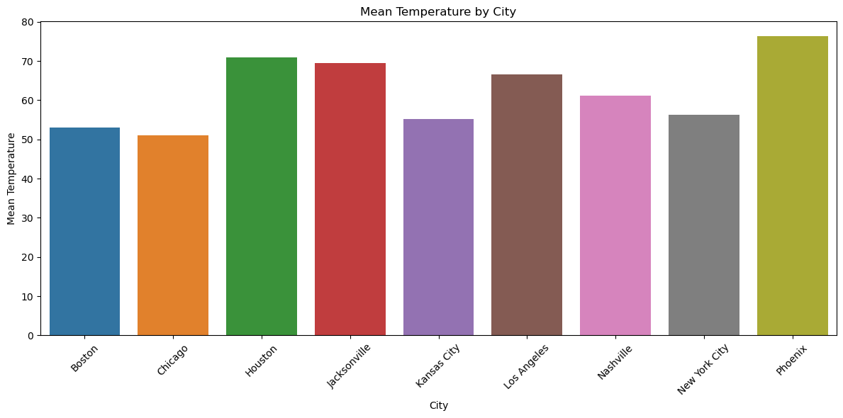

**Figure 2: Mean Number of Disasters by City**

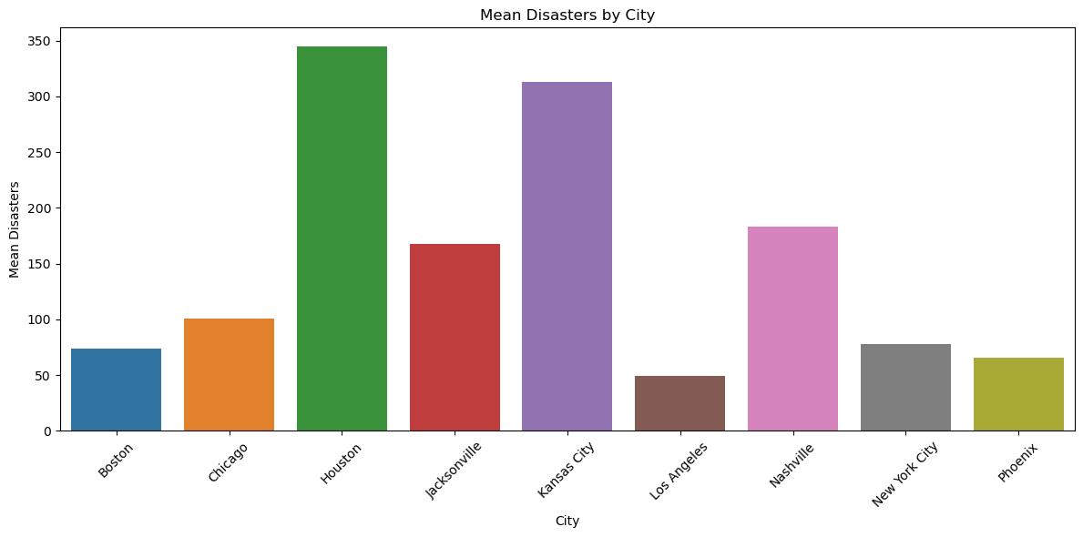

**Figure 3: Mean Rainfall by City**

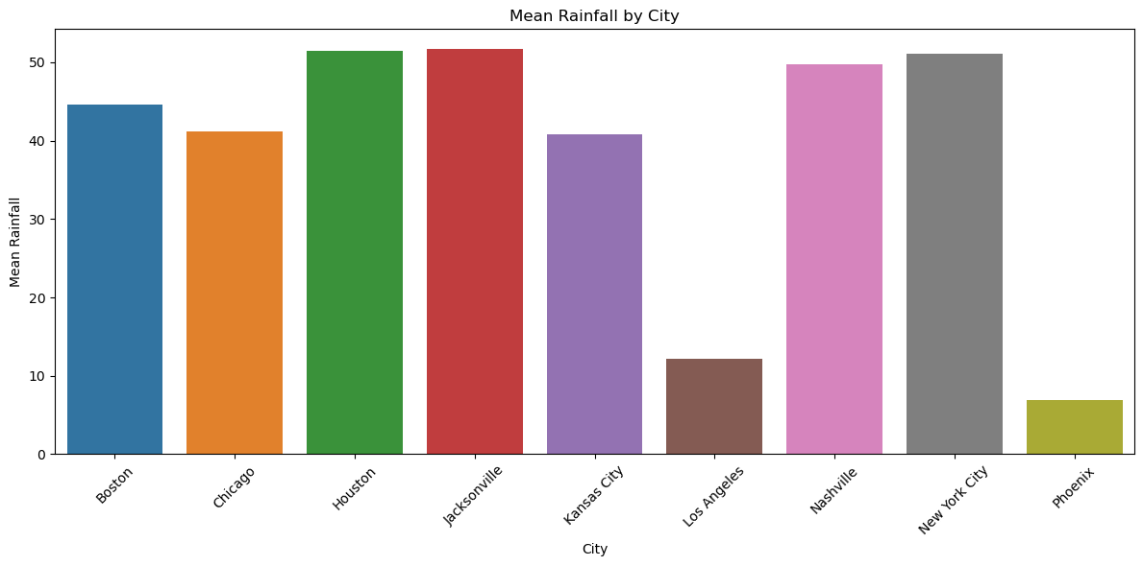

**Figure 4: Mean Snowfall by City**

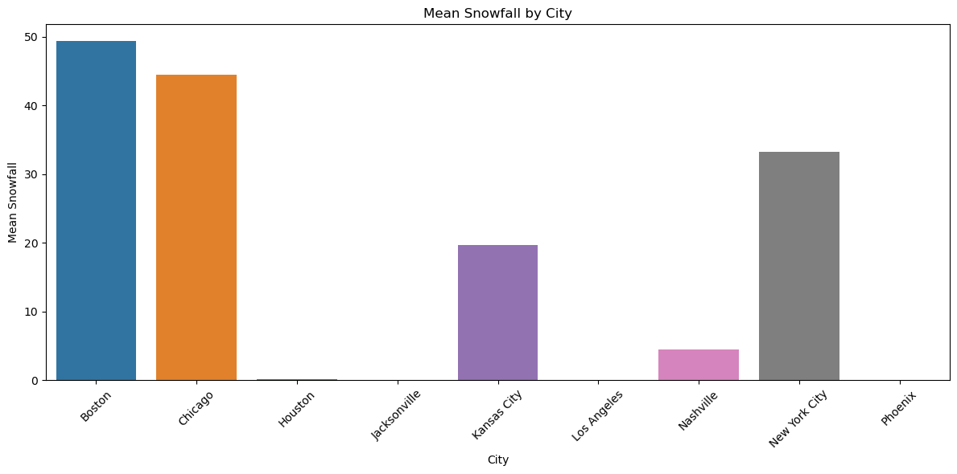

The temperature is consistently distributed across the nine cities, with higher temperatures noted in Houston, Jacksonville, and Phoenix. Conversely, the average number of disasters in Houston, Kansas City, and Nashville is higher from 2008 to 2022. Similarly, Los Angeles and Phoenix experience very low average rainfall, while Boston, Chicago, and New York City have high average snowfall.

**Temporal Analysis**

Further the following plots give trend analysis of age, temperature, snowfall, rainfall, disasters and severe storm warnings.

**Figure 5: Average Age over Time**

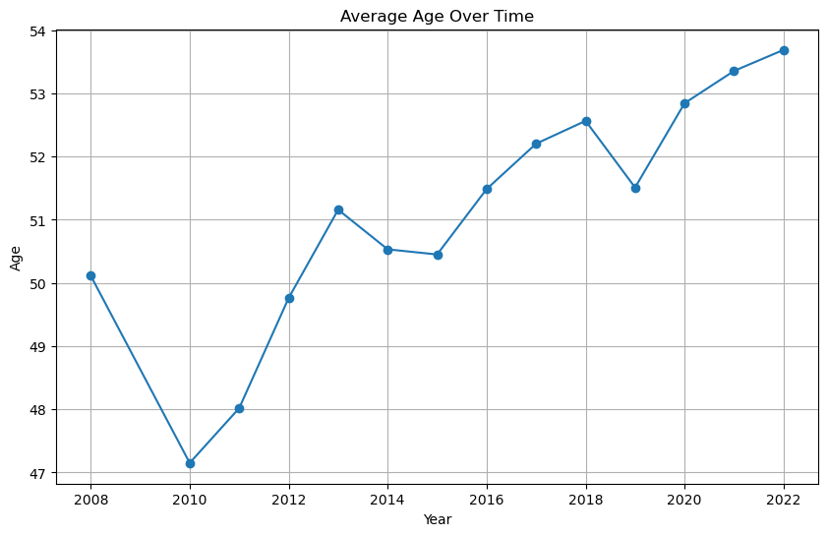

**Figure 6: Average Snowfall over Time**

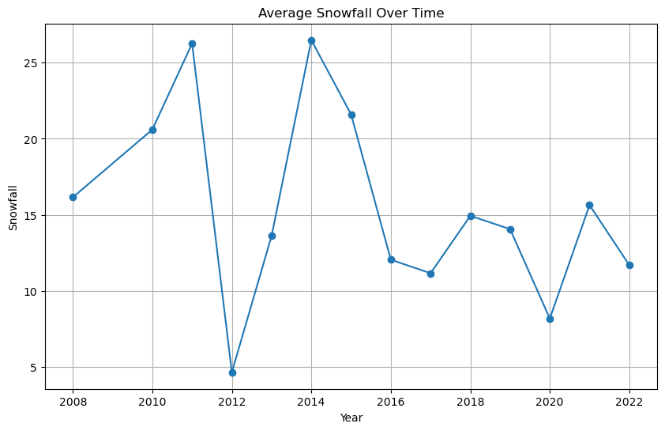

**Figure 7: Average Rainfall over Time**

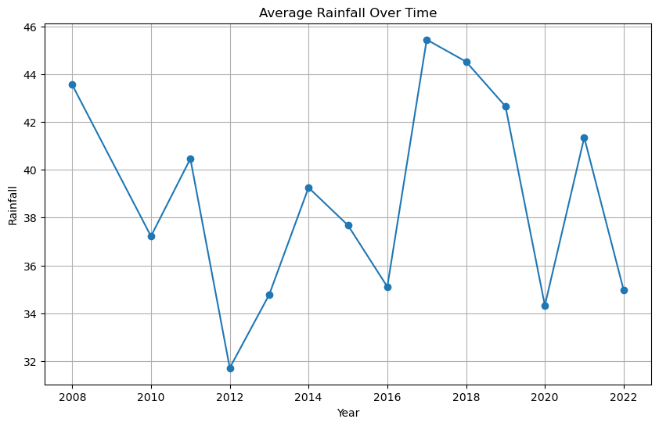

**Figure 8: Average Disasters over Time**

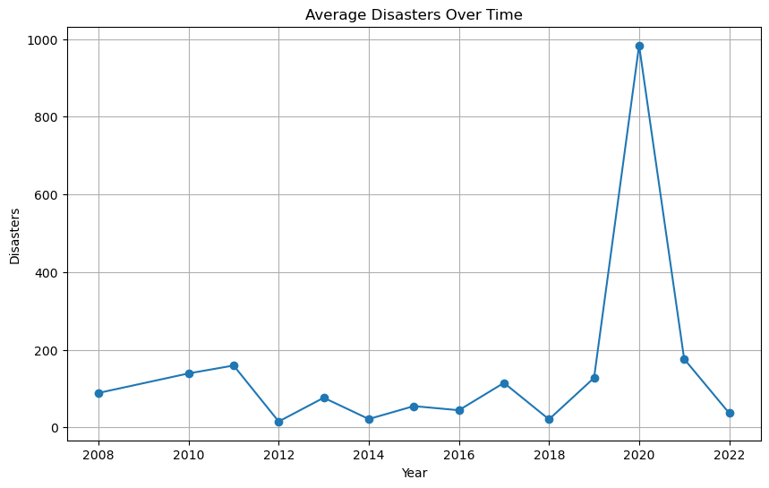

**Figure 9: Average Storms over Time**

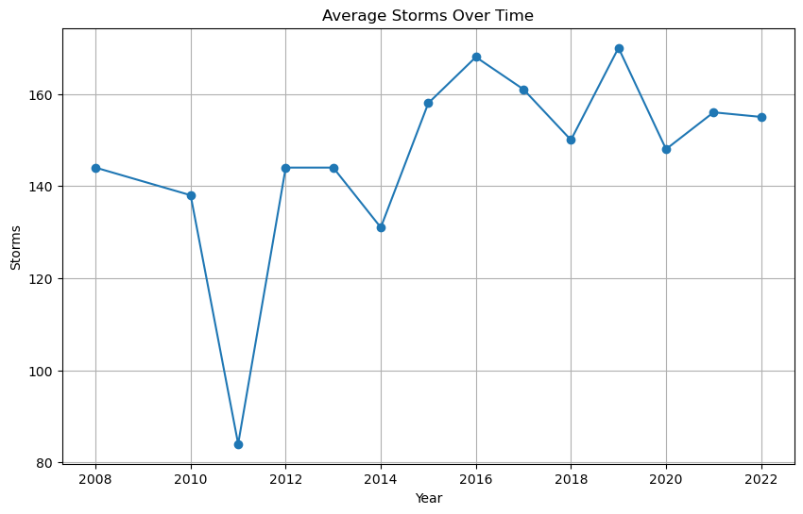

**Figure 10: Average Spending over Time**

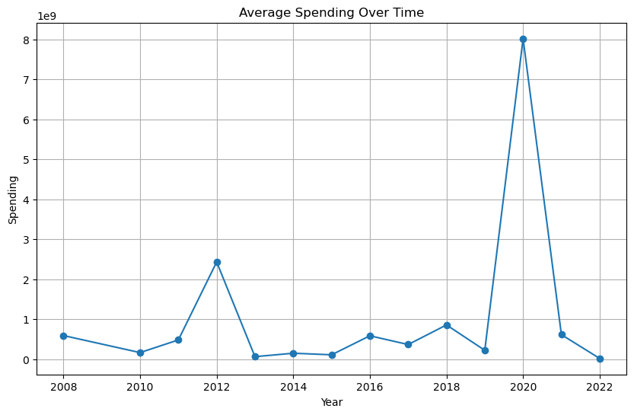

The demographic trend indicates an overall increase in the average age of the population, with a noticeable decline in 2010 followed by a steady rise in subsequent years. Temperature data shows a consistent upward trend over time, with a significant drop in 2014, suggesting a possible long-term warming trend. Snowfall averages exhibit a decreasing pattern with a steep rise in the year 2014, implying a potential decline in snowfall amounts over the years.Rainfall averages initially decrease and then stabilize at a lower level, with an increase in 2017, indicating a shift in rainfall patterns. The average number of natural disasters displays a steady trend, with a sharp rise in 2020. Similarly, the average number of severe storm warnings shows an increasing trend, suggesting a potential increase in the frequency of these events over time.Spending averages over the time with a small rise in 2012 and then there is a steep rise in the year 2020 resembling the rise in disasters in the year 2020 showing the correlation.

**Modeling/Methodology**

We chose to utilize a logistic regression model to evaluate the relationship between a number of demographic, regional weather, and global weather variables. Our methodology was to implement an additive multi-model strategy with a base model, demographics only, serving as a reference and adding variables to answer SMART questions directly. This process resulted in six models, base plus five smart question models, evaluated using logistic regression.

Our base model was built out of the demographic variables identified above with the binary survey question of "Is climate change happening?" as the outcome variable. In the source data, this question has three answers or is missing but we chose to recode it into a binary for the affirmative rather than retain multiple similar responses (“I don’t know” and missing) as levels. We also included the year of the survey as a continuous time variable to help control for variations over time and the geographic region where the respondent resided to help control for difference among regions. More typical demographics including if the respondent was female, their age, their income level, a race variable, a religion variable, an ideology variable, and a political affiliation variable were included in the base model. Marital status and current employment were excluded from the final model due to high correlations with age and education was excluded due to low variance in the unadjusted survey data. Number of children in the household and number of adults in the household were also excluded due to exceeding low covariance with all variables excluding age. Finally, snowfall was excluded from smart question focused regressions as multiple of the regions received no snowfall during the entirety of the evaluative period.

Before creating models with the variables, categorical variables like income, religion, race, ideology, and party are reduced to binary variables to decrease the total number of dummy variables. The reductions performed are shown in Table 4 below:

**Table 4: Categorical Variable Redesign**

| Categorical Variable | Reduced to 1 if | Reduced to 0 if |
| --- | --- | --- |
| Income_encoded | Income above $50,000 | Income below $50,000 |
| Religion | Catholic or Other Christian | All other categories |
| Race | White, Non-Hispanic | All other categories |
| Ideology | Somewhat Conservative or Very Conservative | All other categories |
| Party | Democrat | All other categories |

Before using the aforementioned demographic variables in the model, we standardized the continuous variables using the StandardScaler() in the Scikit-learn library[24].

We utilized a treat/test method to develop a confusion matrix approach for evaluating the effectiveness of each of the included models. The performance of the models can be seen in Table 5 below:

**Table 5: Performance Indicators of Logit Models**

|  | Precision | | Recall | | f1-score | | Accuracy |
| --- | --- | --- | --- | --- | --- | --- | --- |
| Model | 0 | 1 | 0 | 1 | 0 | 1 |
| Base | 0.57 | 0.79 | 0.53 | 0.82 | 0.55 | 0.80 | 0.72 |
| Model 1 | 0.57 | 0.79 | 0.53 | 0.82 | 0.55 | 0.80 | 0.72 |
| Model 2 | 0.57 | 0.79 | 0.53 | 0.82 | 0.55 | 0.80 | 0.72 |
| Model 3 | 0.57 | 0.79 | 0.53 | 0.82 | 0.55 | 0.80 | 0.72 |
| Model 4 | 0.57 | 0.79 | 0.53 | 0.82 | 0.55 | 0.80 | 0.72 |
| Model 5 | 0.57 | 0.79 | 0.53 | 0.82 | 0.55 | 0.80 | 0.73 |

Given that we combined several responses to represent the “0” value, we focus on predicting “1” or that climate change is happening for evaluating our models. An accuracy score of 0.72 is a good score to start with, but there is room for improvement given the size of the data set we were working with. Based on our research questions, the base model is modified by adding relevant variables (specific to the smart questions). Adding additional variables with predictive power might have been assumed to improve the various assessment scores but we found no substantive differences in the predictive power of the model by adding new variables to the base model. That said, it should also be noted that our goal was not to improve the predictive accuracy of the models. We are only interested in observing the coefficients and significance levels to determine answers to our smart questions.

# Results

We ran six logit regression models, a base model plus five models to answer each smart question, to better understand how locally experienced weather impacts an individual’s opinion on if climate change is happening. The signs and significance of the results are presented in Table 6 below. Coefficients for these results can be found in Appendix B.

**Table 6: Sign and Significance of Logit Model Coefficients**

|  | Base | Model 1 | Model 2 | Model 3 | Model 4 | Model 5 |
| --- | --- | --- | --- | --- | --- | --- |
| Intercept | 0 | 0 | 0 | 0 | 0 | 0 |
| Year | + | + | + | + | + | + |
| Female | 0 | 0 | 0 | 0 | 0 | 0 |
| Age | 0 | 0 | 0 | 0 | 0 | 0 |
| Income <$50k | + | + | + | + | + | 0 |
| East-South Central | - | - | - | - | - | - |
| Mid-Atlantic | + | + | 0 | + | 0 | + |
| Mountain | + | + | 0 | + | 0 | + |
| New England | + | + | + | + | 0 | + |
| Pacific | + | + | 0 | + | 0 | + |
| South Atlantic | + | + | 0 | + | 0 | + |
| West-North Central | 0 | 0 | 0 | 0 | 0 | 0 |
| West-South Central | 0 | 0 | 0 | 0 | 0 | 0 |
| Race | 0 | 0 | 0 | 0 | 0 | 0 |
| Ideology | - | - | - | - | - | - |
| Party | + | + | + | + | + | + |
| Religion | 0 | 0 | 0 | 0 | 0 | 0 |
| Global Temp | X | 0 | X | X | X | X |
| Rainfall | X | X | 0 | X | 0 | X |
| City Temp | X | X | 0 | X | + | X |
| El Nino | X | X | X | - | - | X |
| Storms | X | X | X | X | X | + |
| Disasters | X | X | X | X | X | 0 |
| Spending | X | X | X | X | X | 0 |

From the above symbol table, there are a few variables that are consistently positively related to the opinion that climate change is happening. Generally, income above $50k, and identifying as being part of the Democratic party were significantly positively related to believing that climate change is happening. Conversely, identifying as having an ideology of being conservative or somewhat conservative was always negatively related with this opinion. Being white, christian, or female was consistently unrelated to their opinion of if climate change was happening.

Most interestingly among the variables in the base model, there was a clear delineation between regions in regard to belief in climate change happening. The New-England and Pacific regions were frequently significantly positively correlated with believing that climate change was happening while the East-South Central region was frequently significantly negatively correlated with that opinion across all models. Despite strong indicators that global warming was impacting local weather patterns and extreme weather was occurring in the remaining regions, none of the most impacted regions were significant in any of the six models.

Our five models including the variables of interest resulted in generally small impacts on the coefficients in the base models. Global temperature, rainfall, number of disasters, and disaster spending were found to be insignificantly related to the opinion that climate change was happening. However, regional temperature and el Nino/la Nina pattern was found to be significantly related to individual’s opinion on if climate change was happening. As this data was regional, the corresponding coefficients on most regional dummies became insignificant after the inclusion of these variables indicating that they represented a stronger predictor of the outcome variable than the regional dummies. Similarly, including the number of severe storms in the model also changed the regional variables by bringing significance to the south-atlantic (which is typically highly impacted by severe weather including hurricanes) and reducing the income above $50k indicator to insignificance.

# Conclusion

We find that how individuals experience local weather likely does influence their opinion of if climate change is happening. This result is likely strongly correlated with a regionality and an unobserved social impact which is exogenous from the data used in this modeling. The reason why we assume that missing variables might be influencing our results is that the demographics most commonly associated with climate change denial were found to be strong and consistent predictors in each variant of our logit models.

That said, we do postulate that there is some impact on opinions of climate change derived specifically from the increasing rate of severe storms and overall trends in rising local temperatures. However, the scale of this impact is impossible to say from this work as we do not have the actual local weather experiences for each of the individuals in this dataset. Rather, we are inferring trends using regions and therefore generalizing much of what might be important individualized information.

Finally, we find that el Nino/la nina weather patterns do seem to have some impact on local weather experience and thus should be considered in future work on this subject. Again, we lack individualized weather experience data so this may be an artifact of regionally applied weather data, but the manner in which the index seems to have adjusted climate change opinions is consistent with what we might expect for an intensifying weather pattern despite its cyclical nature.

# Discussion

While some of the local weather variables, local rainfall, global temperature, and disasters, were not found to be related to an individual’s opinion if climate change is happening, the strong and direct impacts of temperature and severe storms support our predictions that an individual’s experience with weather influences their opinion of climate change. These results parallel those found in other studies but shouldn’t be taken as direct evidence of their impact. There are several limitations inherent in this methodology which may bring our conclusions into doubt.

As mentioned above, the data for weather we included was entirely applied at a regional or global level and not at the individual level. During our data collection we noticed that even small changes in geography could significantly impact an individual’s experience and thus any findings using weather data should be closely examined in this light. We do not argue that our treatment is fully correct, or that even the directions of the results are accurate, only that the indication of a relationship exists.

We also recognise that our treatment of time as a continuous variable isn’t fully warranted in a model with obvious time series implications. We could have appropriately utilized a year dummy to help control for exogenous impacts and we did consider doing so. However, we chose to assume a linear relationship with time as both the climate change index and the el Nino/la Nina indexes also assumed linear time. Using time as a continuous variable also helped control the dimensionality of the model which had the benefit of allowing us to more quickly process our analysis and thus test more concepts within the available time frame.

Finally, we fully recognise that there are additional methods for model selection which we have not discussed. A stepwise reduction in dimensionality was considered but the practical implications of such a computationally intensive model were daunting. Similarly, we considered a difference in difference method, as well as other semi-experimental methods, but were unable to identify appropriate pre/post splits in the data to justify these types of models.

# Appendix A: Principal Component Analysis

As part of our EDA work we chose to examine if it was feasible to utilize Principal Component Analysis (PCA) to reduce the dimensionality of the model(s). The results of a 5 component analysis is shown in Table A1 below:

**Table A1: Principal Components Analysis of Base Model**

|  | PC1 | PC2 | PC3 | PC4 | PC5 |
| --- | --- | --- | --- | --- | --- |
| age | -0.0755 | 0.0582 | 0.1039 | -0.6292 | 0.03815 |
| c_temp | -0.176 | -0.5814 | -0.1425 | -0.0603 | 0.0364 |
| snowfall | 0.1934 | 0.5745 | 0.1341 | 0.0666 | -0.0236 |
| rainfall | 0.0238 | 0.2662 | 0.2913 | 0.0512 | -0.5872 |
| disasters | -0.1623 | -0.1531 | 0.6174 | 0.133 | -0.0808 |
| storms | -0.4729 | 0.1531 | -0.1838 | 0.0112 | -0.0296 |
| spending | -0.1399 | -0.1673 | 0.5643 | 0.1207 | 0.2785 |
| el_nino | -0.3045 | 0.1985 | -0.3277 | 0.081 | -0.0727 |
| g_temp | -0.5454 | 0.1475 | 0.0253 | 0.0832 | 0.0282 |
| g_temp_lowess | -0.5062 | 0.1295 | 0.0762 | 0.0123 | 0.024 |
| children | 0.0715 | -0.0714 | -0.1109 | 0.5824 | -0.0542 |
| adults | 0.0076 | -0.0275 | -0.064 | 0.4545 | 0.0886 |
| population | 0.0651 | 0.3147 | 0.0487 | 0.0403 | 0.7413 |

We have color coded variables that were shown to be strong components in each PC variable. We chose a cutoff +/- 0.3 to highlight strongly involved coefficients as there was a relatively clear split between the strongly related and weakly related components at that value.

The highlighting was done to illustrate the main parts of each component, with green coefficients being positive and red being negative, but we didn’t attempt to interpret the coefficients directly. Rather, we were looking for insights as to which variables clustered together for use in our additive logit design. PC1 demonstrated that the global variables (el_nino, g_temp, and g_temp lowess) were likely controlling for similar variance in the model. Similarly, PC2 showed us that c_temp, snowfall, and rainfall were related while PC3 showed disasters and spending were probably related. These insights helped us craft our regression models by demonstrating which variables should be used together for best effect.

# Appendix B: Regression Results, with Coefficients

While we chose to report only the sign and significance of the logit model results in the body of this paper, the full model results are represented here. We have chosen to use only a ɑ=0.05 cutoff value for significance rather than report full p-values in deference to space.

**Table B1: Regression Coefficients for each of the Logit Models**

|  | **Base** | **Model 1** | **Model 2** | **Model 3** | **Model 4** | **Model 5** |
| --- | --- | --- | --- | --- | --- | --- |
| **Intercept** | 0.895382 | 0.895448 | 0.895529 | 0.895528 | 0.895687 | 0.896701 |
| **Year** | 0.135791* | 0.156511* | 0.123599* | 0.142185* | 0.129264* | 0.084314* |
| **Female** | 0.026028 | 0.026023 | 0.026194 | 0.026159 | 0.026317 | 0.027407 |
| **Age** | 0.017081 | 0.016810 | 0.017189 | 0.016539 | 0.016617 | 0.016049 |
| **Income under $50k** | 0.121700* | 0.121490* | 0.121446* | 0.120909* | 0.120568* | 0.122191 |
| **East-South Central** | -0.066469* | -0.066529* | -0.119938* | -0.066780* | -0.125399* | -0.068537* |
| **Mid-Atlantic** | 0.042893* | 0.042800* | 0.000373 | 0.042412* | -0.004747 | 0.043820* |
| **Mountain** | 0.034744* | 0.034757* | 0.109641 | 0.034481* | -0.125859 | 0.035152* |
| **New England** | 0.080219* | 0.080123* | 0.070136* | 0.080039* | 0.069042 | 0.081176* |
| **Pacific** | 0.093298* | 0.093296* | -0.026906 | 0.093169* | -0.040871 | 0.094006* |
| **South Atlantic** | 0.044301* | 0.044155* | -0.124494 | 0.043854* | -0.141431 | 0.041993* |
| **West-North Central** | 0.004531 | 0.004518 | -0.021050 | 0.004523 | -0.023693 | 0.000981 |
| **West-South Central** | 0.019894 | 0.019906 | -0.120369 | 0.019492 | -0.134499 | 0.013341 |
| **Race** | 0.018088 | -0.018109 | -0.018077 | -0.018034 | -0.017991 | -0.019046 |
| **Ideology** | -0.566146* | -0.566146* | -0.566276* | -0.566340* | -0.566504* | -0.566433* |
| **Party** | 0.541172* | 0.541218* | 0.541297* | 0.541220* | 0.541364* | 0.540872* |
| **Religion** | 0.004227 | 0.004198 | 0.004034 | 0.004091 | 0.003870 | 0.004825 |
| **Global Temp** | X | -0.025177 | X | X | X | X |
| **Rainfall** | X | X | 0.014363 | X | 0.013020 | X |
| **City Temp** | X | X | 0.190287 | X | 0.209436* | X |
| **El Nino** | X | X | X | -0.034355* | -0.036648* | X |
| **Storms** | X | X | X | X | X | 0.082678* |
| **Disasters** | X | X | X | X | X | 0.022228 |
| **Spending** | X | X | X | X | X | 0.007490 |

* *p-value < 0.05*

**Appendix C, Table 1:** Covariance matrix of variables after recoding

|  | age | c_temp | rainfall | disasters | storms | spending | el_nino | g_temp | happening | female | race |
| --- | --- | --- | --- | --- | --- | --- | --- | --- | --- | --- | --- |
| age | 286.1225 | -0.3616 | 4.2942 | 61.5466 | 21.2555 | 9.65E+08 | 0.0443 | 0.1612 | -0.1625 | -0.0428 | 1.1525 |
| c_temp | -0.3616 | 70.3043 | -42.3310 | 215.0070 | 10.0392 | 3.25E+09 | 0.0952 | 0.0990 | 0.0395 | -0.0181 | -0.5417 |
| rainfall | 4.2942 | -42.3310 | 344.4983 | 749.3451 | 4.3061 | 2.00E+09 | -0.2022 | 0.0016 | -0.1885 | 0.0856 | 0.4247 |
| disasters | 61.5466 | 215.0070 | 749.3451 | 89242.6200 | -164.5047 | 5.22E+11 | -29.1651 | 11.4270 | 1.4370 | 0.6095 | -2.0321 |
| storms | 21.2555 | 10.0392 | 4.3061 | -164.5047 | 407.9583 | -2.21E+08 | 5.9244 | 2.0579 | 0.5248 | -0.1124 | -0.1605 |
| spending | 9.65E+08 | 3.25E+09 | 2.00E+09 | 5.22E+11 | -2.21E+08 | 1.02E+19 | -1.90E+08 | 7.61E+07 | 3.92E+07 | 2.85E+06 | -5.60E+07 |
| el_nino | 0.0443 | 0.0952 | -0.2022 | -29.1651 | 5.9244 | -1.90E+08 | 0.3955 | 0.0461 | -0.0006 | 0.0002 | -0.0030 |
| g_temp | 0.1612 | 0.0990 | 0.0016 | 11.4270 | 2.0579 | 7.61E+07 | 0.0461 | 0.0224 | 0.0035 | 0.0000 | -0.0026 |
| happening | -0.1625 | 0.0395 | -0.1885 | 1.4370 | 0.5248 | 3.92E+07 | -0.0006 | 0.0035 | 0.2183 | 0.0092 | -0.0170 |
| female | -0.0428 | -0.0181 | 0.0856 | 0.6095 | -0.1124 | 2.85E+06 | 0.0002 | 0.0000 | 0.0092 | 0.2500 | -0.0019 |
| race | 1.1525 | -0.5417 | 0.4247 | -2.0321 | -0.1605 | -5.60E+07 | -0.0030 | -0.0026 | -0.0170 | -0.0019 | 0.1913 |
| ideology | 0.9542 | 0.0832 | 0.1581 | 0.5963 | -0.1139 | -1.99E+07 | -0.0017 | -0.0015 | -0.0757 | -0.0155 | 0.0291 |
| party | 0.0293 | -0.0186 | -0.0380 | -1.2120 | 0.0384 | 1.89E+07 | -0.0003 | 0.0000 | 0.0634 | 0.0187 | -0.0435 |
| religion | -0.0108 | -0.2211 | -0.0888 | -1.0308 | -0.1213 | 3.34E+06 | -0.0007 | -0.0006 | -0.0025 | 0.0036 | -0.0083 |
| year | 5.8217 | 2.4922 | 1.6426 | 296.7010 | 42.0424 | 2.07E+09 | 0.3820 | 0.4778 | 0.1165 | 0.0046 | -0.0743 |
| income_encoded | -0.0365 | -0.0176 | -0.2199 | 4.0320 | 0.5094 | 5.53E+07 | -0.0016 | 0.0062 | 0.0089 | -0.0141 | 0.0210 |
| East-South Central | -0.0539 | -0.0865 | 0.5782 | 2.0602 | -0.0176 | -4.23E+07 | -0.0006 | -0.0006 | -0.0060 | 0.0000 | 0.0035 |
| Mid-Atlantic | 0.0594 | -0.8591 | 1.5958 | -8.9676 | -0.0896 | 5.40E+07 | -0.0009 | -0.0002 | 0.0042 | 0.0007 | 0.0016 |
| Mountain | 0.0019 | 1.0275 | -2.4401 | -5.9812 | 0.0210 | -5.62E+07 | -0.0004 | 0.0001 | -0.0009 | 0.0005 | 0.0003 |
| New England | 0.0611 | -0.4704 | 0.2661 | -3.4468 | -0.0142 | -2.59E+07 | -0.0007 | -0.0001 | 0.0022 | -0.0006 | 0.0058 |
| Pacific | -0.0777 | 0.6153 | -4.1638 | -14.7239 | 0.0538 | 1.69E+07 | 0.0015 | 0.0005 | 0.0084 | -0.0028 | -0.0189 |
| South Atlantic | 0.0923 | 1.3298 | 2.4325 | 4.4463 | 0.0678 | 4.95E+07 | -0.0003 | 0.0002 | 0.0001 | 0.0005 | -0.0038 |
| West-North Central | -0.0250 | -0.5627 | 0.1298 | 12.7692 | -0.0537 | -3.56E+07 | 0.0004 | -0.0003 | -0.0023 | 0.0013 | 0.0116 |
| West-South Central | -0.0753 | 0.8570 | 1.2818 | 20.8457 | 0.0124 | 1.49E+08 | -0.0010 | 0.0004 | -0.0024 | -0.0001 | -0.0140 |

**Appendix C, Table 2**: Covariance matrix of variables after recoding (cont.)

|  | ideology | party | religion | year | income_encoded | East-South Central | Mid-Atlantic | Mountain | New England | Pacific | South Atlantic | West-North Central | West-South Central |
| --- | --- | --- | --- | --- | --- | --- | --- | --- | --- | --- | --- | --- | --- |
| age | 0.9542 | 0.0293 | -0.0108 | 5.8217 | -0.0365 | -0.0539 | 0.0594 | 0.0019 | 0.0611 | -0.0777 | 0.0923 | -0.0250 | -0.0753 |
| c_temp | 0.0832 | -0.0186 | -0.2211 | 2.4922 | -0.0176 | -0.0865 | -0.8591 | 1.0275 | -0.4704 | 0.6153 | 1.3298 | -0.5627 | 0.8570 |
| rainfall | 0.1581 | -0.0380 | -0.0888 | 1.6426 | -0.2199 | 0.5782 | 1.5958 | -2.4401 | 0.2661 | -4.1638 | 2.4325 | 0.1298 | 1.2818 |
| disasters | 0.5963 | -1.2120 | -1.0308 | 296.7010 | 4.0320 | 2.0602 | -8.9676 | -5.9812 | -3.4468 | -14.7239 | 4.4463 | 12.7692 | 20.8457 |
| storms | -0.1139 | 0.0384 | -0.1213 | 42.0424 | 0.5094 | -0.0176 | -0.0896 | 0.0210 | -0.0142 | 0.0538 | 0.0678 | -0.0537 | 0.0124 |
| spending | -1.99E+07 | 1.89E+07 | 3.34E+06 | 2.07E+09 | 5.53E+07 | -4.23E+07 | 5.40E+07 | -5.62E+07 | -2.59E+07 | 1.69E+07 | 4.95E+07 | -3.56E+07 | 1.49E+08 |
| el_nino | -0.0017 | -0.0003 | -0.0007 | 0.3820 | -0.0016 | -0.0006 | -0.0009 | -0.0004 | -0.0007 | 0.0015 | -0.0003 | 0.0004 | -0.0010 |
| g_temp | -0.0015 | 0.0000 | -0.0006 | 0.4778 | 0.0062 | -0.0006 | -0.0002 | 0.0001 | -0.0001 | 0.0005 | 0.0002 | -0.0003 | 0.0004 |
| happening | -0.0757 | 0.0634 | -0.0025 | 0.1165 | 0.0089 | -0.0060 | 0.0042 | -0.0009 | 0.0022 | 0.0084 | 0.0001 | -0.0023 | -0.0024 |
| female | -0.0155 | 0.0187 | 0.0036 | 0.0046 | -0.0141 | 0.0000 | 0.0007 | 0.0005 | -0.0006 | -0.0028 | 0.0005 | 0.0013 | -0.0001 |
| race | 0.0291 | -0.0435 | -0.0083 | -0.0743 | 0.0210 | 0.0035 | 0.0016 | 0.0003 | 0.0058 | -0.0189 | -0.0038 | 0.0116 | -0.0140 |
| ideology | 0.2212 | -0.0807 | 0.0078 | -0.0478 | 0.0076 | 0.0046 | -0.0063 | 0.0025 | -0.0030 | -0.0081 | 0.0015 | 0.0022 | 0.0052 |
| party | -0.0807 | 0.2206 | -0.0044 | -0.0085 | -0.0054 | -0.0027 | 0.0044 | -0.0043 | -0.0012 | 0.0078 | 0.0020 | -0.0035 | -0.0023 |
| religion | 0.0078 | -0.0044 | 0.2246 | -0.0206 | 0.0063 | -0.0070 | 0.0094 | -0.0017 | 0.0049 | 0.0024 | -0.0140 | -0.0010 | 0.0031 |
| year | -0.0478 | -0.0085 | -0.0206 | 15.4363 | 0.2197 | -0.0200 | -0.0077 | 0.0053 | 0.0001 | 0.0099 | 0.0135 | -0.0112 | 0.0126 |
| income_encoded | 0.0076 | -0.0054 | 0.0063 | 0.2197 | 0.2314 | -0.0063 | 0.0034 | -0.0009 | 0.0035 | 0.0070 | 0.0006 | 0.0013 | -0.0059 |
| East-South Central | 0.0046 | -0.0027 | -0.0070 | -0.0200 | -0.0063 | 0.0513 | -0.0073 | -0.0041 | -0.0026 | -0.0084 | -0.0105 | -0.0041 | -0.0057 |
| Mid-Atlantic | -0.0063 | 0.0044 | 0.0094 | -0.0077 | 0.0034 | -0.0073 | 0.1159 | -0.0101 | -0.0065 | -0.0207 | -0.0260 | -0.0101 | -0.0140 |
| Mountain | 0.0025 | -0.0043 | -0.0017 | 0.0053 | -0.0009 | -0.0041 | -0.0101 | 0.0699 | -0.0037 | -0.0117 | -0.0147 | -0.0057 | -0.0079 |
| New England | -0.0030 | -0.0012 | 0.0049 | 0.0001 | 0.0035 | -0.0026 | -0.0065 | -0.0037 | 0.0461 | -0.0075 | -0.0094 | -0.0037 | -0.0051 |
| Pacific | -0.0081 | 0.0078 | 0.0024 | 0.0099 | 0.0070 | -0.0084 | -0.0207 | -0.0117 | -0.0075 | 0.1306 | -0.0300 | -0.0117 | -0.0161 |
| South Atlantic | 0.0015 | 0.0020 | -0.0140 | 0.0135 | 0.0006 | -0.0105 | -0.0260 | -0.0147 | -0.0094 | -0.0300 | 0.1566 | -0.0147 | -0.0203 |
| West-North Central | 0.0022 | -0.0035 | -0.0010 | -0.0112 | 0.0013 | -0.0041 | -0.0101 | -0.0057 | -0.0037 | -0.0117 | -0.0147 | 0.0701 | -0.0079 |
| West-South Central | 0.0052 | -0.0023 | 0.0031 | 0.0126 | -0.0059 | -0.0057 | -0.0140 | -0.0079 | -0.0051 | -0.0161 | -0.0203 | -0.0079 | 0.0936 |

1. IPCC, 2023: *Summary for Policymakers. In: Climate Change 2023: Synthesis Report. Contribution of Working Groups I, II and III to the Sixth Assessment Report of the Intergovernmental Panel on Climate Change* [Core Writing Team, H. Lee and J. Romero (eds.)]. IPCC, Geneva, Switzerland, pp. 1-34, doi: 10.59327/IPCC/AR6-9789291691647.001
2. Palm, R., Lewis, G. B., & Feng, B. (2017). What Causes People to Change Their Opinion about Climate Change? *Annals of the American Association of Geographers*, *107*(4), 883–896. https://doi.org/10.1080/24694452.2016.1270193
3. Hansen, J. (2004). Defusing the global warming time bomb. *Scientific American*, *290*(3), 68-77.
4. Shabecoff, P. (1988). Global warming has begun, expert tells Senate. *New York Times*, *24*(1988), A1.
5. Dunlap, R. E. (2013). Climate change skepticism and denial: An introduction. *American behavioral scientist*, *57*(6), 691-698.
6. Gifford R. (2011). The dragons of inaction: psychological barriers that limit climate change mitigation and adaptation. *The American psychologist*, *66*(4), 290–302. https://doi.org/10.1037/a0023566
7. Hansen, J., Sato, M., & Ruedy, R. (2012). Perception of climate change. *Proceedings of the National Academy of Sciences*, *109*(37), E2415-E2423.
8. Howe, P. D. (2018). Perceptions of seasonal weather are linked to beliefs about global climate change: evidence from Norway. *Climatic Change*, *148*, 467-480.
9. Gärtner, L., & Schoen, H. (2021). Experiencing climate change: revisiting the role of local weather in affecting climate change awareness and related policy preferences. *Climatic Change*, *167*(3-4), 31.
10. Bergquist, M., Nilsson, A., & Schultz, P. W. (2019). Experiencing a severe weather event increases concern about climate change. Front. Psychol., 10.
11. Howe, P. D. (2021). Extreme weather experience and climate change opinion. *Current Opinion in Behavioral Sciences*, *42*, 127-131.
12. Moore, F. C., Obradovich, N., Lehner, F., & Baylis, P. (2019). Rapidly declining remarkability of temperature anomalies may obscure public perception of climate change. *Proceedings of the National Academy of Sciences*, *116*(11), 4905-4910.
13. Shao, W., & Goidel, K. (2016). Seeing is believing? An examination of perceptions of local weather conditions and climate change among residents in the US Gulf Coast. *Risk Analysis*, *36*(11), 2136-2157.
14. Palutikof, J. P., Agnew, M. D., & Hoar, M. R. (2004). Public perceptions of unusually warm weather in the UK: impacts, responses and adaptations. *Climate Research*, *26*(1), 43-59.
15. Ballew, M. T., Leiserowitz, A., Roser-Renouf, C., Rosenthal, S. A., Kotcher, J. E., Marlon, J. R., Lyon, E., Goldberg, M. H., & Maibach, E. W. (2019). *Climate Change in the American Mind: Data, tools, and trends. Environment: Science and Policy for Sustainable Development, 61*(3), 4-18. doi: [10.1080/00139157.2019.1589300](https://www.tandfonline.com/doi/full/10.1080/00139157.2019.1589300)
16. Federal Emergency Management Agency (FEMA), OpenFEMA Dataset: Disaster Declarations Summaries - v2. Retrieved from<https://www.fema.gov/openfema-data-page/disaster-declarations-summaries-v2> on April 4th, 2024.
17. Federal Emergency Management Agency (FEMA), OpenFEMA Dataset:Hazard Mitigation Assistance Projects - v3. Retrieved fromhttps://www.fema.gov/openfema-data-page/hazard-mitigation-assistance-projects-v3 on April 4th, 2024.
18. Federal Emergency Management Agency (FEMA), OpenFEMA Dataset:Public Assistance Funded Projects Details - v1. Retrieved fromhttps://www.fema.gov/openfema-data-page/public-assistance-funded-projects-details-v1 on April 4th, 2024.
19. National Weather Service Climate Prediction Center, Cold & Warm Episodes by Season dataset. Retrieved from <https://origin.cpc.ncep.noaa.gov/products/analysis_monitoring/ensostuff/ONI_v5.php> on April 4th, 2024.
20. NASA, Global Temperature dataset. Retrieved from <https://climate.nasa.gov/vital-signs/global-temperature/?intent=121> on April 4th, 2024.
21. Cells shaded with gray have Cohen’s f2 effect size <0.02, light green has effect size between 0.02 and 0.20, dark green has effect size >0.50. A shade of green between light and dark would have been used for effect sizes between 0.20 and 0.50, but none were recorded.
22. All recorded Cohen’s d effect sizes recorded were <0.2, since none met the threshold to be considered at least small effects, all were shaded gray.
23. List of principal components and their coefficients can be found in Appendix A
24. Pedregosa, F., Varoquaux, Ga"el, Gramfort, A., Michel, V., Thirion, B., Grisel, O., … others. (2011). Scikit-learn: Machine learning in Python. *Journal of Machine Learning Research*, *12*(Oct), 2825–2830.